AERO1005 MATLAB Coursework 2

Author: Ruijie DAI
Student ID: 20719819
Date of report: 5/5/2026

Task1
a)
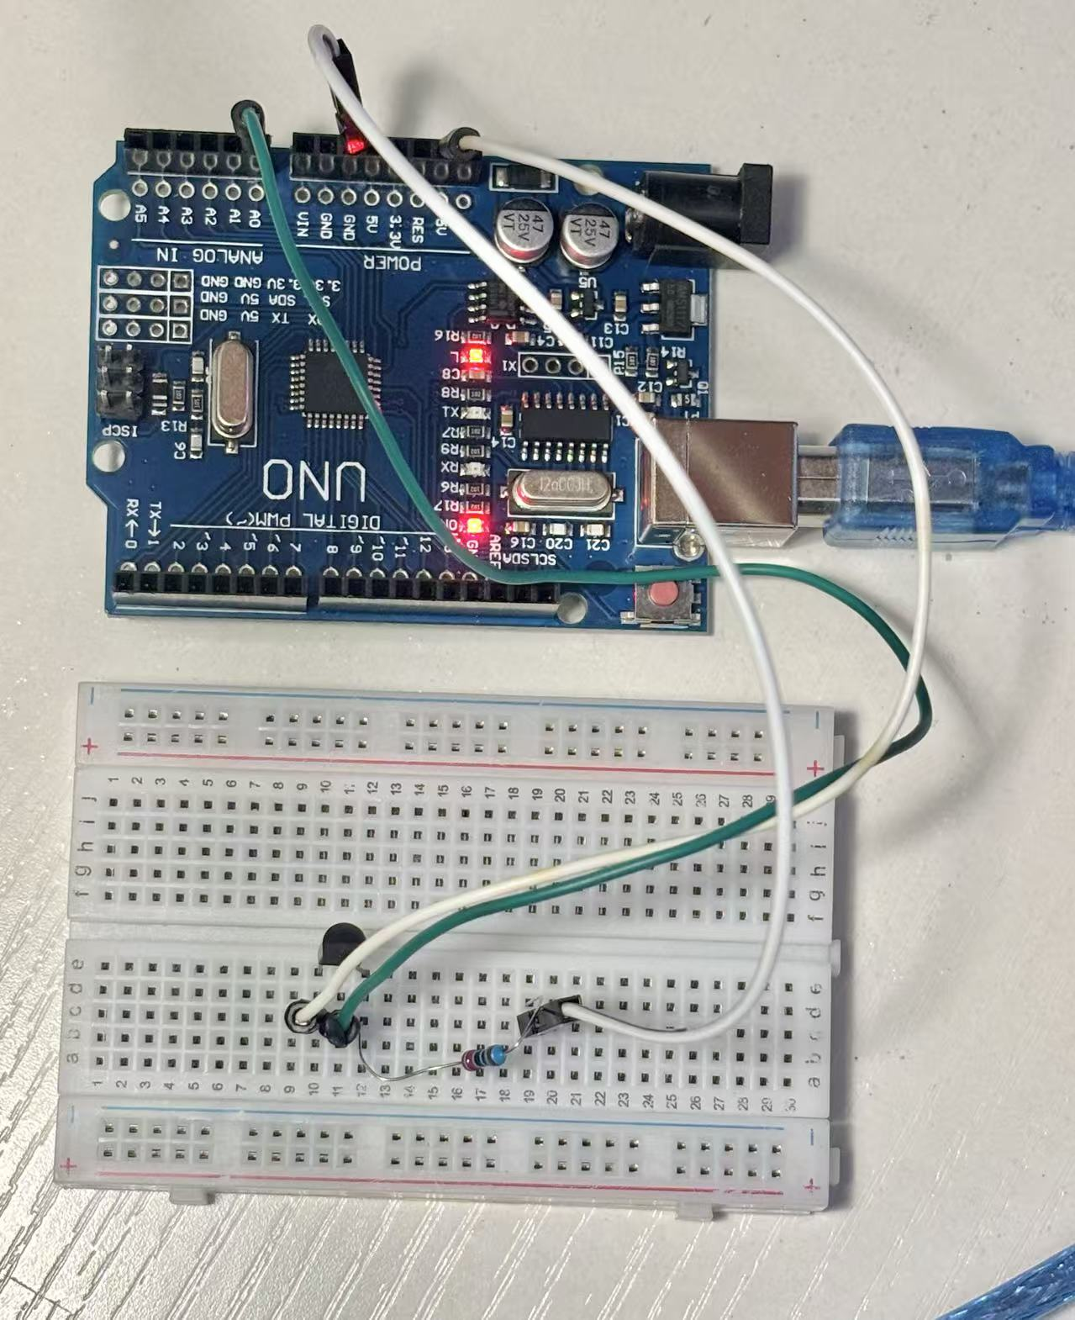
c)
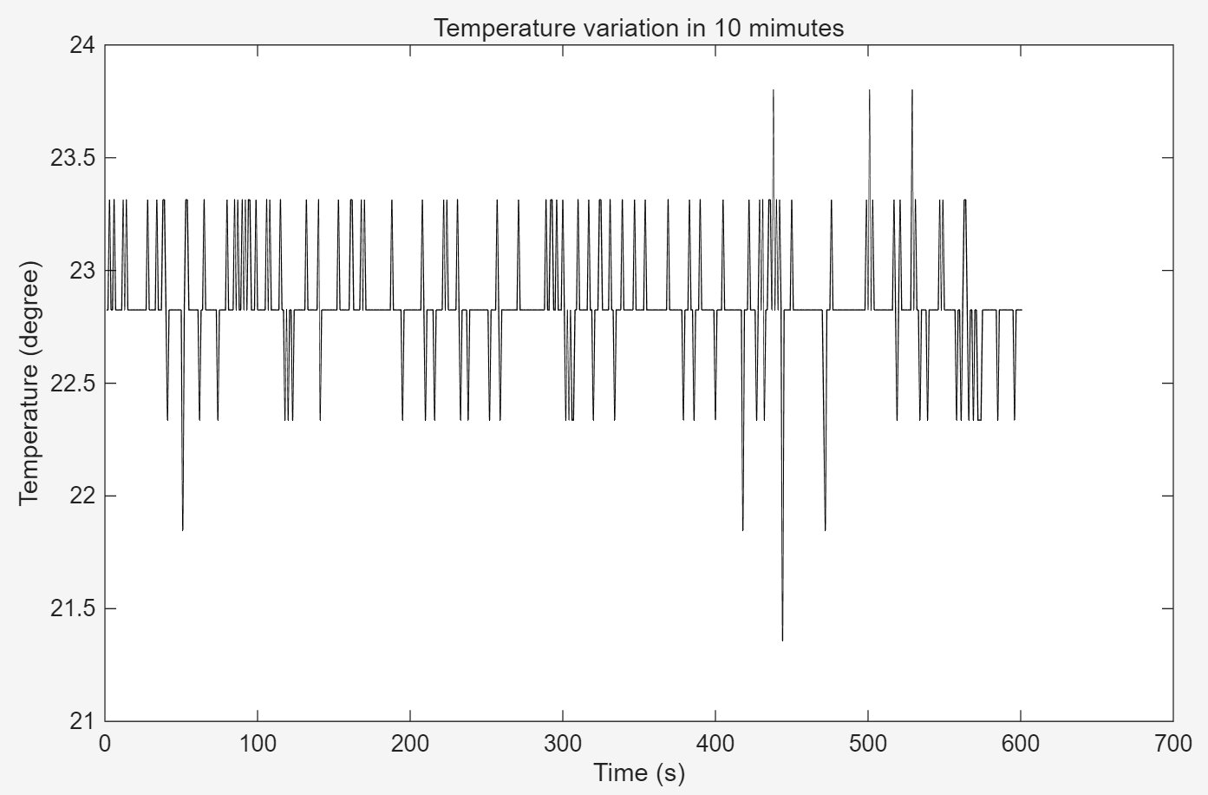

Task2
f)
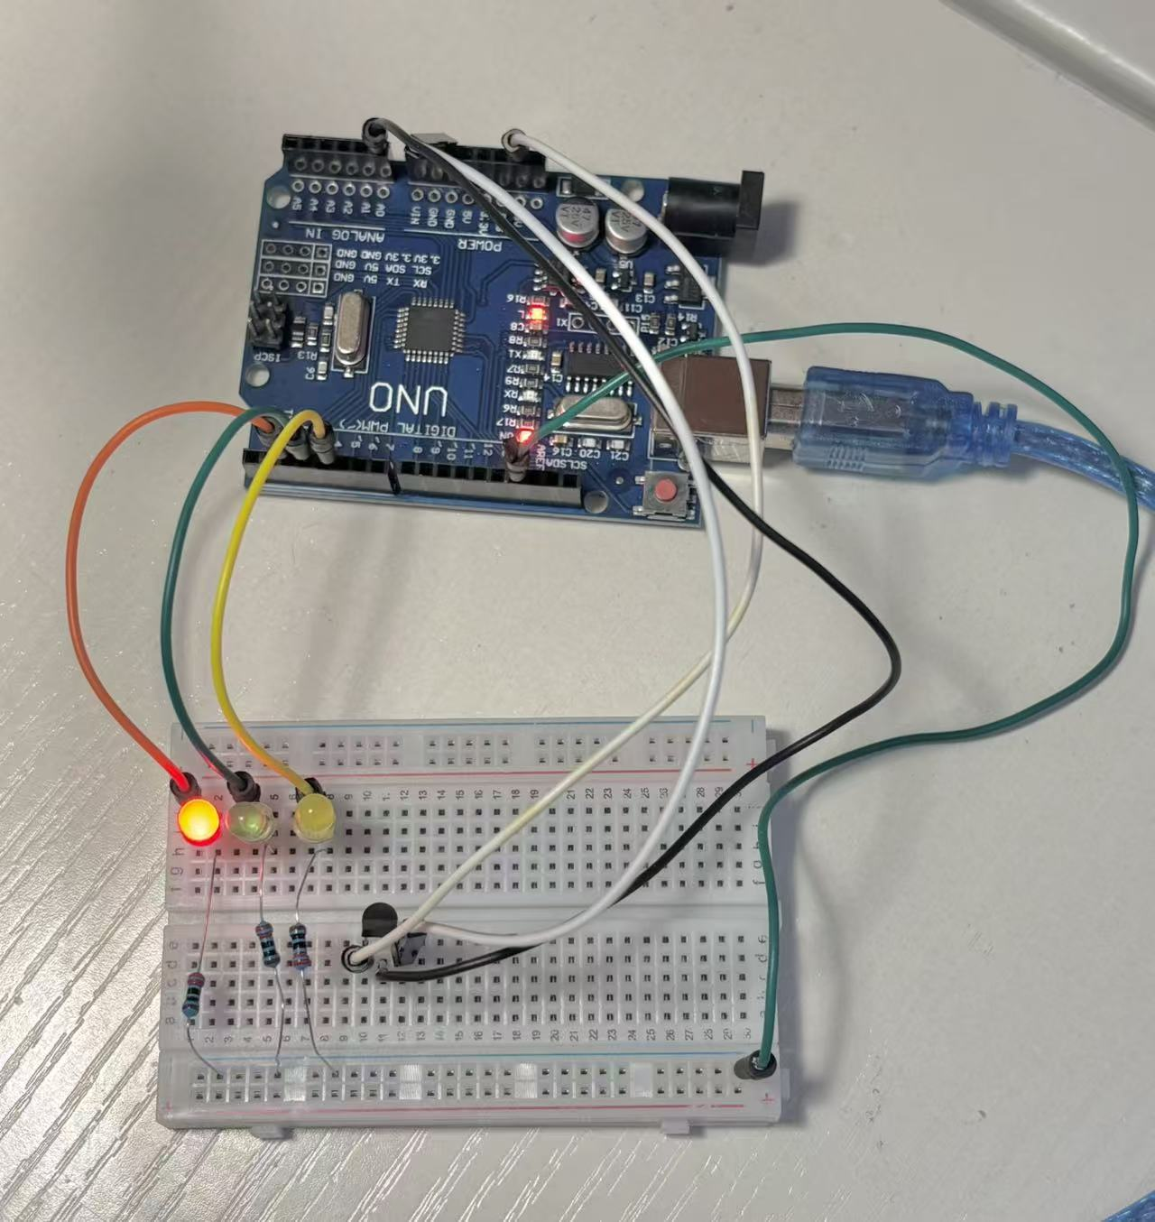
g) Flow Chart1-Before implementation
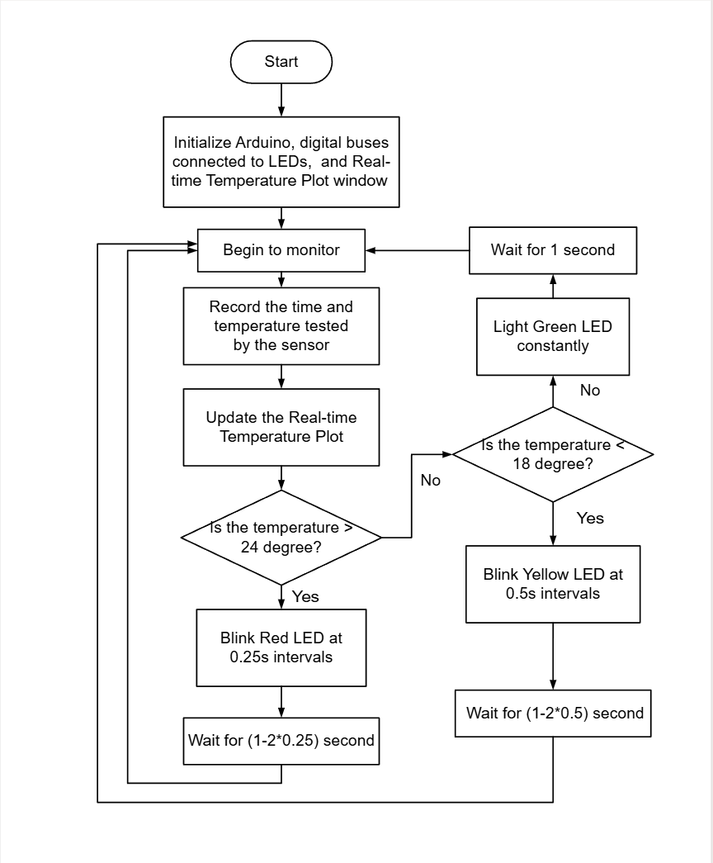

i)
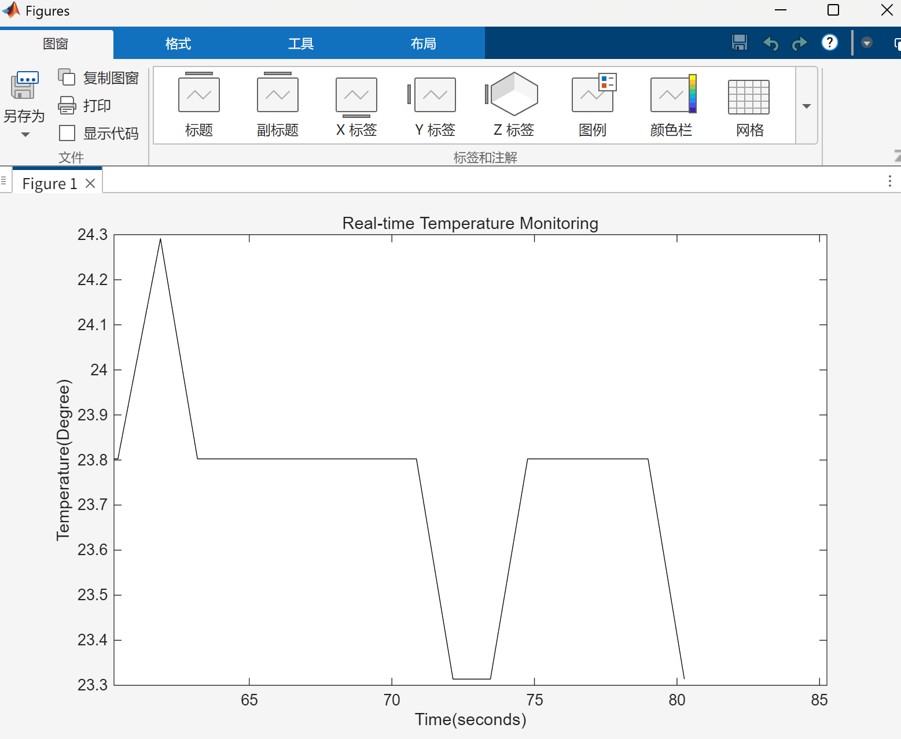

m)g) Flow Chart2-After implementation

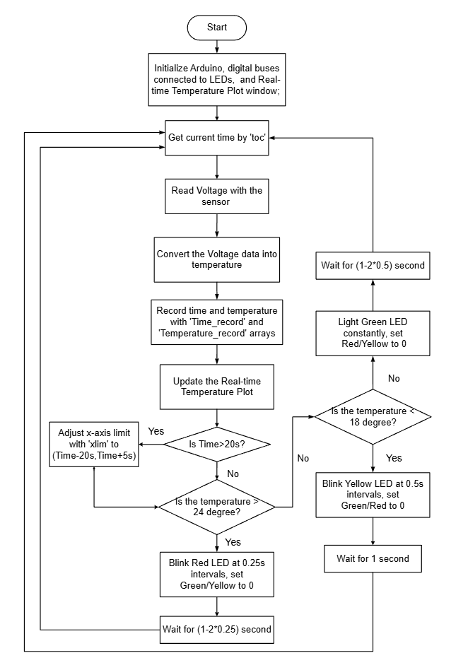

Task3
a)Flow Chart-Before implementation
